EXP 1 : First Palindromic String in an Array

Aim :
To write a Python program to find the first palindromic string in an array of strings and analyze its time complexity.

Algorithm :
- Start.
- Read an array of strings.
- Traverse each string in the array from left to right.
- Check whether the current string is equal to its reverse.
- If it is a palindrome, display it and stop the search.
- If no palindromic string is found, display an empty result.
- Stop.
Source Code :
def is_palindrome(s):
return s == s[::-1]
def first_palindrome(words):
for word in words:
if is_palindrome(word):
return word
return ""
words = ["abc", "car", "ada", "racecar", "cool"]
result = first_palindrome(words)
print("Array:", words)
print("First Palindromic String:", result)

Output :
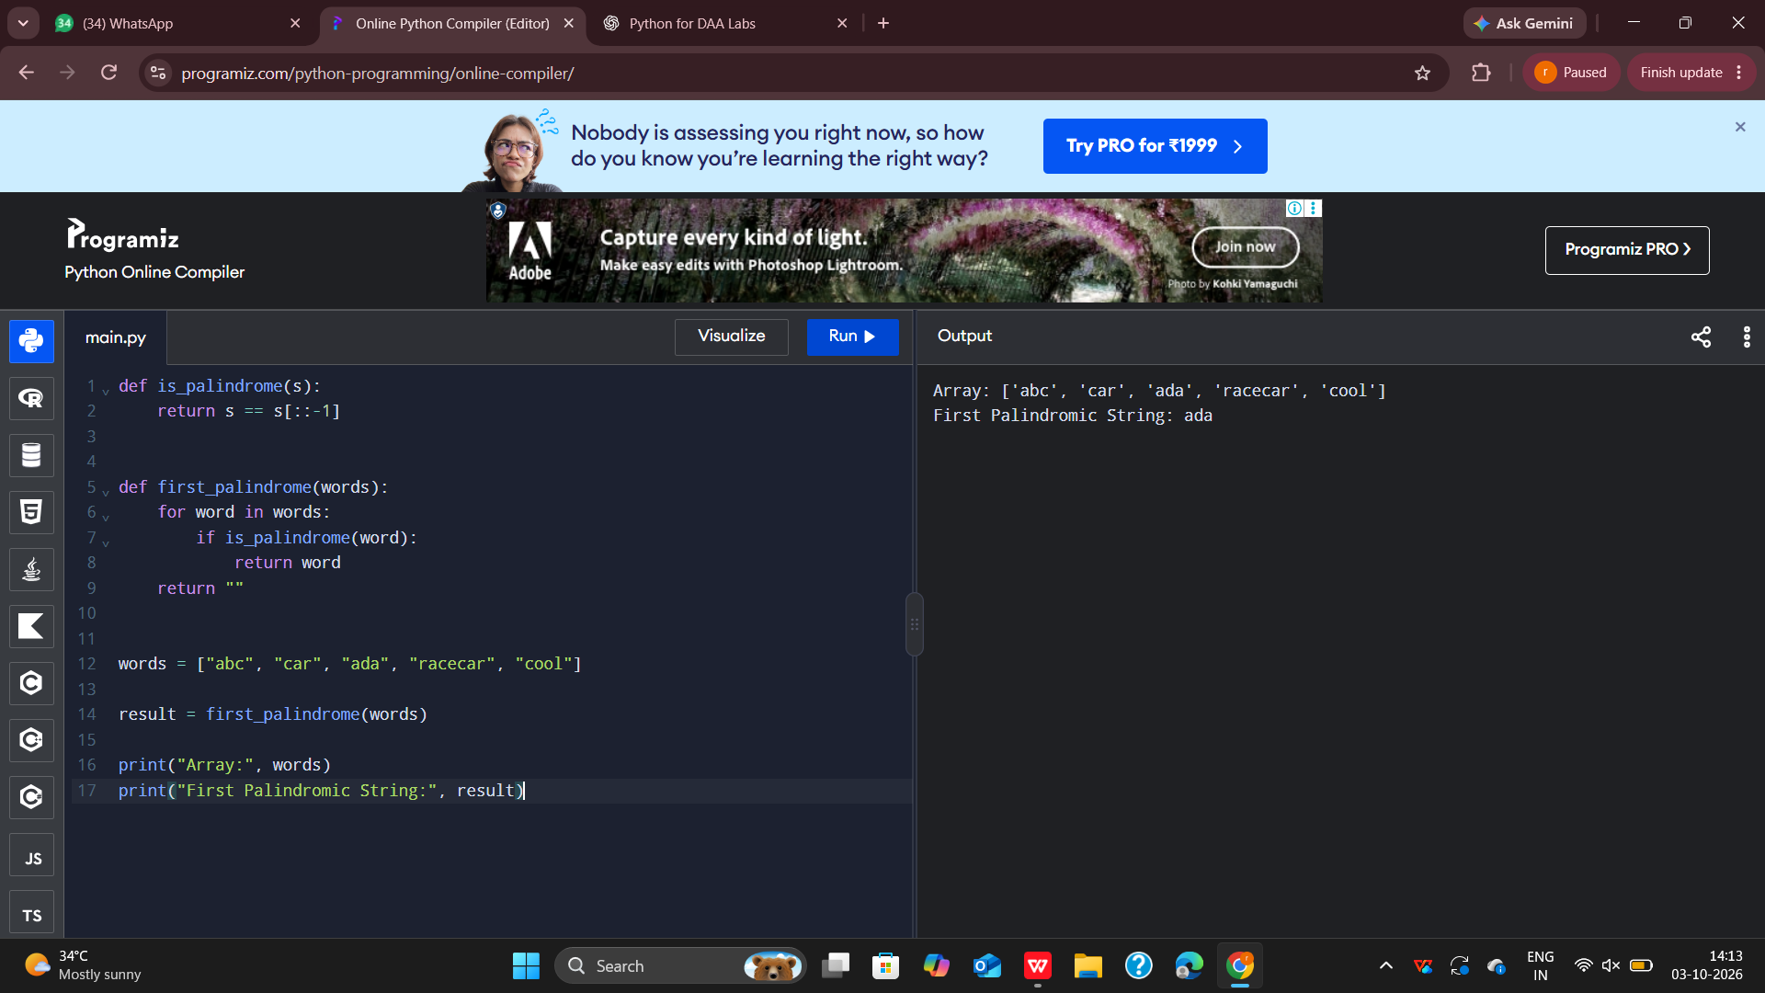
Result :
Thus, the Python program was successfully executed and the first palindromic string in the given array, “ada”, was identified.

Experiment 2: Common Elements Between Two Arrays

Aim
To write a Python program to find the common elements between two arrays and analyze its time complexity.

Algorithm
- Start.
- Read two arrays.
- Convert the second array into a set.
- Traverse each element of the first array.
- Check whether the element exists in the set.
- If it exists, add it to the result.
- Display the common elements.
- Stop.

Source Code
def common_elements(arr1, arr2):
set2 = set(arr2)
result = []

for element in arr1:
if element in set2 and element not in result:
result.append(element)

return result

arr1 = [1, 2, 3, 4, 5]
arr2 = [3, 4, 5, 6, 7]

result = common_elements(arr1, arr2)

print("Array 1:", arr1)
print("Array 2:", arr2)
print("Common Elements:", result)

OUTPUT :

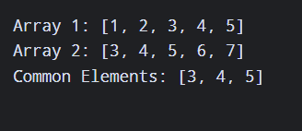

RESULT :
Thus, the Python program was successfully executed and the common elements between the two given arrays, 3, 4, and 5, were identified.

